

# TIJUANA INSTITUTE OF TECHNOLOGY ACADEMIC

**DEPARTMENT OF SYSTEMS AND COMPUTATION COMPUTER**

# SYSTEMS ENGINEERING SEMESTER

FEBRUARY- JULY 2022

# SUBJECT

BDD-1703SC9C Data Mining

# Activity

Evaluation

# Teacher

MC JOSE CHRISTIAN ROMERO HERNANDEZ

# Student

17212327 -Aldarete Delgado Angel Esteban 17210659 - Villegas Carmona Damaris

Tijuana, BC April 04, 2022

**Instrucciones**

**Desarrolle el siguiente problema con R y RStudio para la extracción de conocimiento**

## que el problema requiere.

The directors of the movie review website are very happy with their previous installment and now they have a new requirement for you.

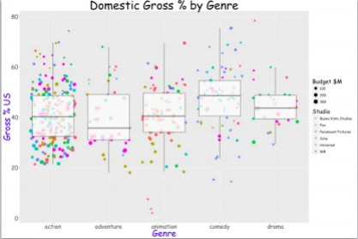The previous consultant had created a chart for them which is illustrated in the image below.

However, the R code used to create the plot has been lost and cannot be recovered. Your task is to create the code that will recreate the same graph making it look as close to the original as possible.

growth

**1.-** We will start by installing the “ggplot2” library, which helps us with the plots. Once installed, we import the required information through a Dataset (which was provided by the teacher from his repository).

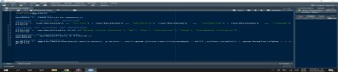

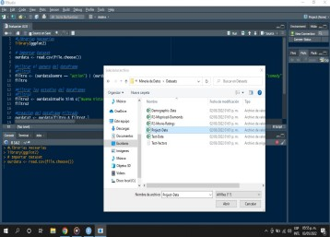

**2.-** Next, through two Datafream we are going to ﬁlter information through its genre and study of the ﬁlm.

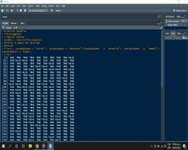

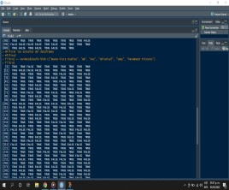

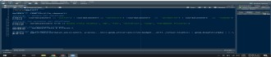**3.-**Oncetheﬁltersaredone,withthehelpofanotherDatafreamwearegoingtoﬁlterthe information in an orderly manner

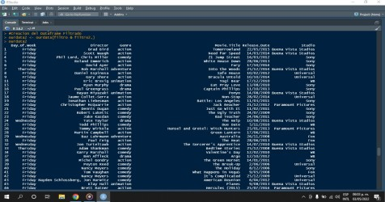

**4.-** In order to represent the data obtained we are going to create the graph and if everything goes well we will obtain a graph that is as similar as possible to what was requested in practice.

**Conclusion:**

As a general conclusion we can say that the action genre in movies is one of the best options that studios take to invest since it is what is sold the most along with comedy but it is in a slightly lower percentage, adventure and animation are not it is the most sought after and therefore not so much is invested in it and finally the drama that although there is not much investment in the same way there is not much interest and profit in this last genre.